**Data structures and Algorithms**

**Week 1 Assignment**

* **Algorithms_Data Structures**

Exercise 1: E-commerce Platform Search Function

**Code:-**

package Week1Assignments.Alogrithm;

import java.util.ArrayList;

import java.util.List;

import java.util.Scanner;

class Product {

    String name;

    double price;

    Product(String name, double price) {

        this.name = name.toLowerCase();

        this.price = price;

    }

    void display() {

        System.out.println("Product: " + name + ", Price: ₹" + price);

    }

}

public class Ecommerce {

    public static void main(String[] args) {

        List<Product> productList = new ArrayList<>();

        productList.add(new Product("Laptop", 65000));

        productList.add(new Product("Smartphone", 25000));

        productList.add(new Product("Smartwatch", 5000));

        productList.add(new Product("Headphones", 2000));

        productList.add(new Product("Tablet", 30000));

        Scanner scanner = new Scanner(System.in);

        System.out.print("Search product by name: ");

        String query = scanner.nextLine().toLowerCase();

        boolean found = false;

        for (Product product : productList) {

            if (product.name.contains(query)) {

                product.display();

                found = true;

            }

        }

        if (!found) {

            System.out.println("No products found matching: " + query);

        }

        scanner.close();

    }

}

// Check if both references are same

System.out.println("Are both objects same? " + (obj1 == obj2));

}

**output:-**

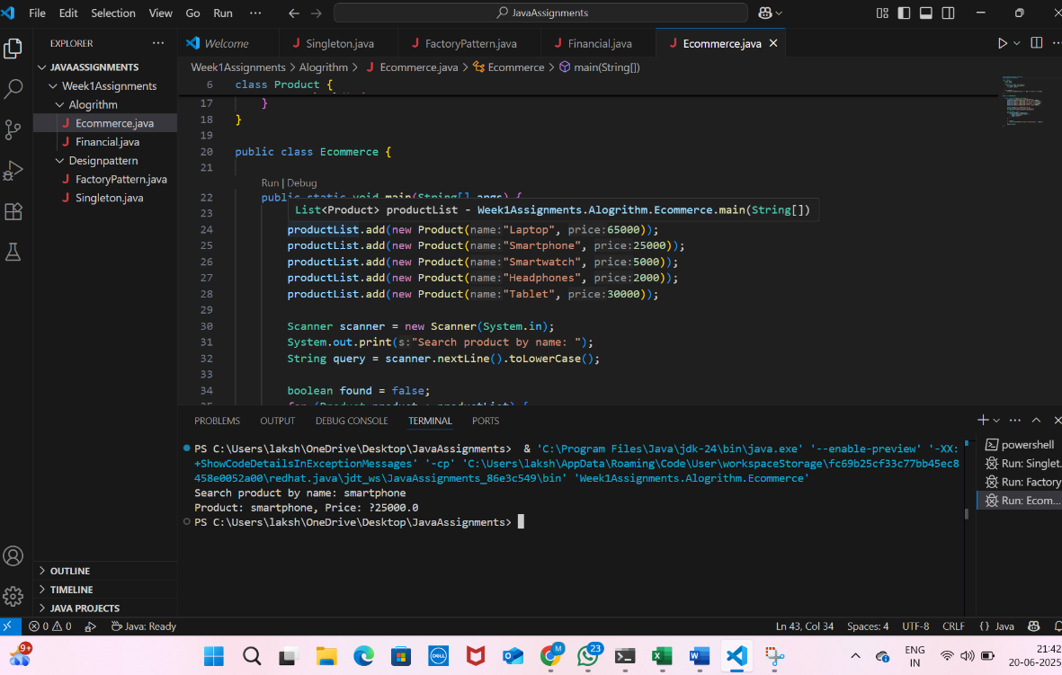

Exercise 2: Financial Forecasting

**Code:-**

import java.util.Scanner;

public class Financial {

    public static double forecastRevenue(double currentRevenue, double growthRate, int years) {

        return currentRevenue * Math.pow(1 + growthRate / 100, years);

    }

    public static void main(String[] args) {

        Scanner scanner = new Scanner(System.in);

        System.out.print("Enter current revenue: ");

        double currentRevenue = scanner.nextDouble();

System.out.print("Enter annual growth rate (%): ");

        double growthRate = scanner.nextDouble();

        System.out.print("Enter number of years to forecast: ");

        int years = scanner.nextInt();

        double futureRevenue = forecastRevenue(currentRevenue, growthRate, years);

        System.out.printf("Forecasted revenue after %d years: %.2f\n", years, futureRevenue);

    scanner.close();

    }

}

**output:-**

